Memory Allocation (Initialization of variables)

Variables which are not dynamically allocated are stored in the stack memory. For example:

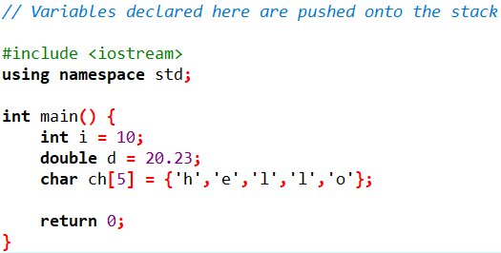

Variables dynamically allocated however are stored in the heap memory. For example:

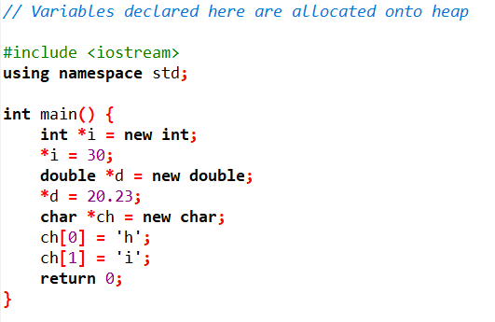

**Stack vs Heap memory allocation**

**Stack:**

* Direct (very fast) access.
* Variables are local to the function and memory gets de-allocated once control exits the function.
* Stored linearly which avoids memory fragmentation.
* Predefined limit on memory size.

**Heap:**

* Global but relatively slower access.
* Memory tends to get fragmented as it is allocated and deallocated.
* Memory needs to be freed manually

E.g. **delete** keyword

* No limit on memory size.